St Hugh’s School

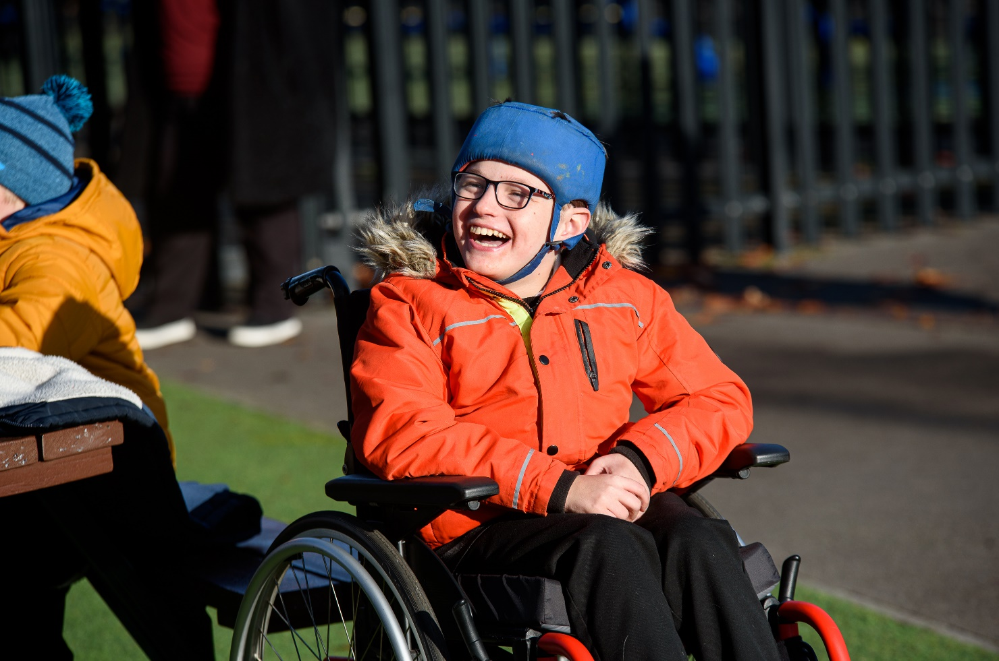
Special Educational Needs and Disabilities (SEND)

Annual Report - Parent Information
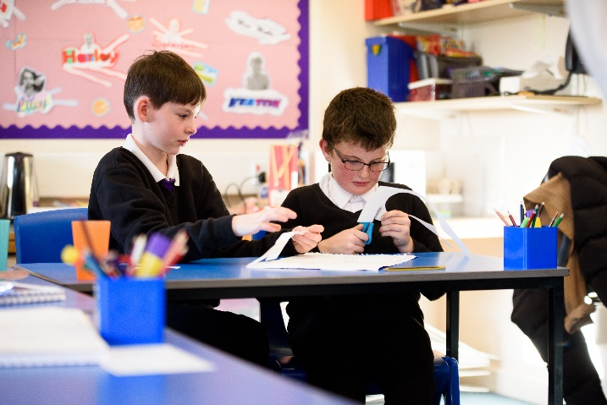 | At St Hugh’s we ensure students are offered support, education and the wide range of opportunities that they deserve in order to reach their full potential.  We are committed to meeting the needs of all students. We share the expectation that all learners, regardless of their specific need, access a full and differentiated curriculum enabling them to make the best possible progress. The values and principles in our mission statement create an ethos in school that ensures all students feel valued members of the school community.  We aim to ensure that our learners leave school as responsible and confident young people with a love of learning and a breadth of skills to enable them to make a positive contribution to life in their local communities.
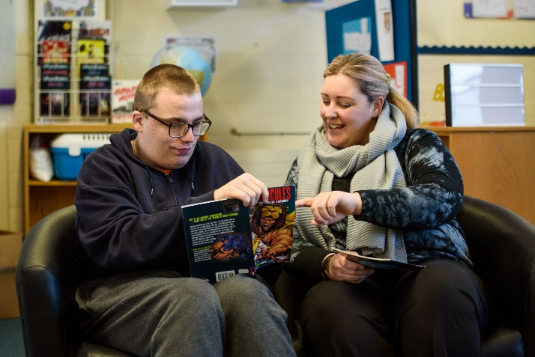
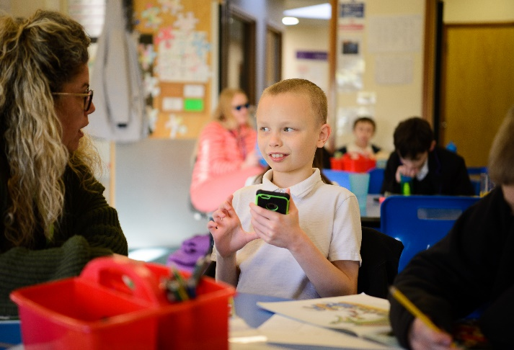
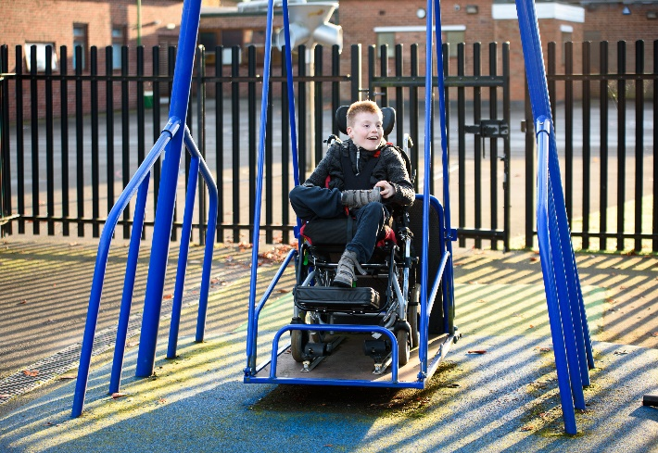

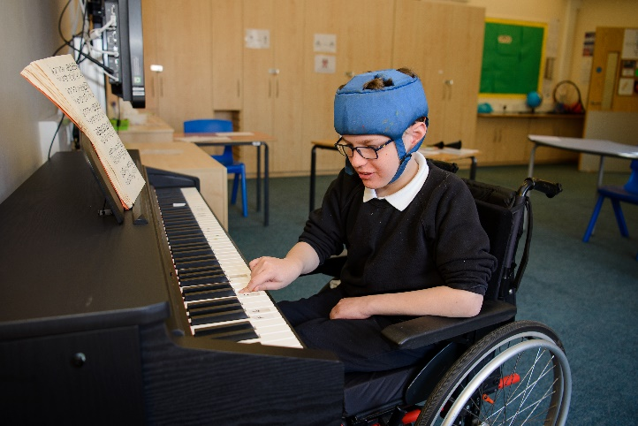
Contents

What kind of Special Educational Needs and Disabilities does St Hugh’s deliver provision for?  How do we identify and assess students’ Special Educational Needs and Disabilities?  How do we consult with you about your child’s needs?  How will we consult with your child about their needs?  What makes us a specialist provision?  What expertise and training do staff have to support pupils with Special Educational Needs and Disabilities?  What arrangements are in place for assessing and reviewing students’ progress?  What access arrangements are there for tests and examinations?  How do we measure the effectiveness of our provision?  What support do we offer to improve student’s emotional and social development?  Which professional partners do we work with?  How do we prepare students for the future?  Additional Information | Page 4  Page 5  Page 6  Page 6  Page 7  Page 8  Page 9  Page 10  Page 10  Page 11  Page 12  Page 13  Page 14
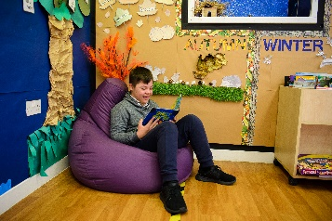

What kind of Special Educational Needs and Disabilities does St Hugh’s deliver provision for?
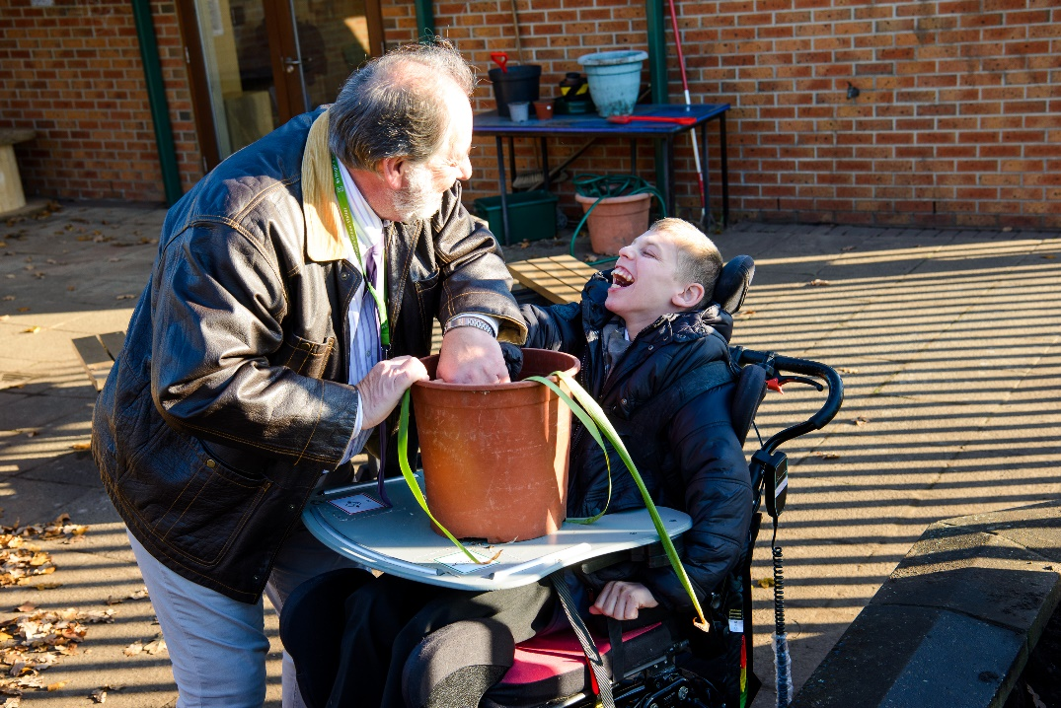
The SEND Code of Practice 2014 defines a child as having a special educational need if they have ‘a significantly greater difficulty in learning than the majority of others at the same age’ or ‘has a disability which prevents or hinders a child from making use of facilities of a kind generally provided for others at the same age in a mainstream school’.

We provide an education for students with significant needs in the following areas:
- Communication and interaction
- Cognition and learning
- Social, emotional and mental health
- Sensory and/or physical needs

All students at St Hugh’s have an identified learning need.

How do we identify and assess students’ Special Educational Needs and Disabilities?
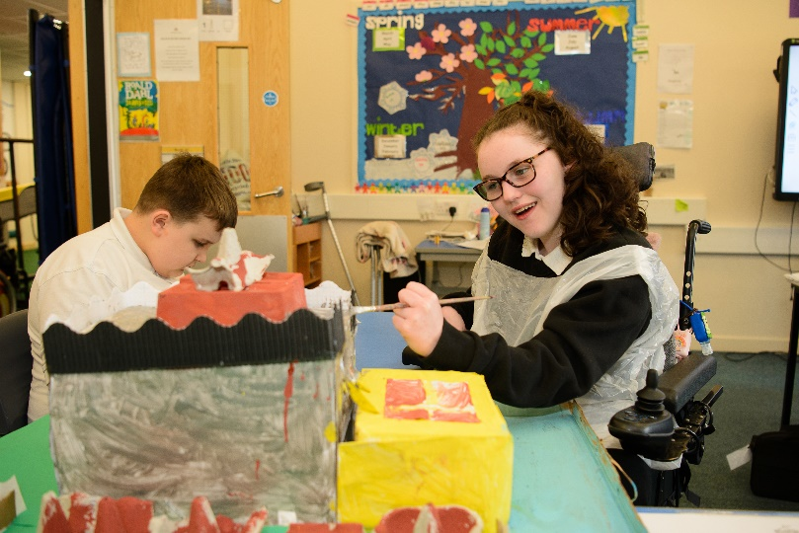
All students who attend St Hugh’s have a Special Educational Need or Disability. The admissions process is through direct consultation with the local authority SEN department. Their contact number is 01724 297148 if further advice is required. A range of assessment information is used at St Hugh’s:
- Student progress (assessed termly)
- Teacher assessment
- Internal tests
- Medical advice and recommendations
- Parent information
- Multi-disciplinary team reports and assessments
- Transition information
- Annual audits across all areas
As St Hugh’s is a specialist school, all teaching staff have SENDCO responsibilities. If you are concerned about your child’s progress you should initially talk with your child’s teacher. If you have further concerns you can contact the Assistant Head Teachers, Deputy Head or Head Teacher via the school’s office (01724 842960).
How do we consult with you about your child’s needs?
Teachers communicate regularly with parents/carers either by telephone, email, parental app or in the home school journalwhich ever is best at suiting your and your child’s own individual needs.
All plans that are put into action, such as moving and handling plans, are always completed in consultation with parents and approved by all parties. Parents and carers are welcome to visit the school and we hold termly parents events to further encourage this. Every student also has an annual review of their Education Health and Care Plan.

How will we consult with your child about their needs?
 | Teachers are effective in using a range of strategies to communicate with students about how well they can do and how they can achieve really well. When outside agencies come in to work with your child, they will discuss what they are going to do and provide age-appropriate materials to ensure individuals’ wishes and feelings are captured. Careers and progression is included in the learning programmes from year 7 upwards.
What makes us a specialist provision?
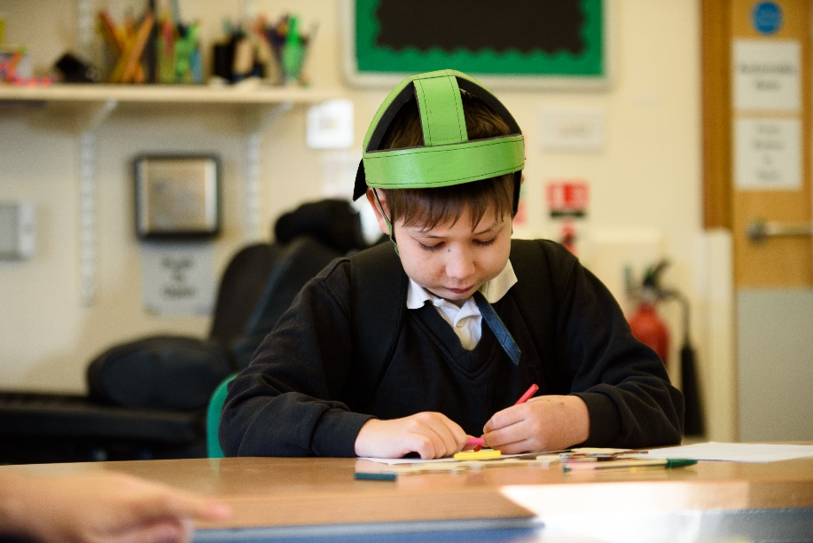
At St Hugh’s we use a range of resources and specialist support to create an inclusive learning environment that enables learners to achieve their full potential. Examples include:
- Hydrotherapy pool
- Sensory multi-media studio
- Electronic doors and access to promote independence
- Play areas equipped with all-weather musical instruments and play equipment
- Sensory intervention resources
- Sensory garden
- Hygiene suite and adapted bathrooms and changing facilities
- Hoisting and ceiling tracking
- Subject specific and specialist interventions
- Appropriate staffing levels for small class teaching
- Varied specialist approaches to teaching in order to maximise students’ learning
- Resources which are appropriate to the needs, abilities and age of students
- Personalised and/or modified timetable coverage
- Use of alternative assessments
- Augmentative and alternative communication methods
- A range of therapeutic support
- A highly specialist staff team
- Appropriate accreditation routes at KS4 and KS5
- Fully adapted curriculum which enables all students to demonstrate good progress.
 |  |  |  | 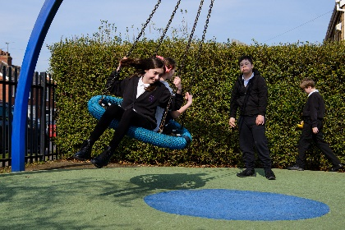
What expertise and training do staff have to support pupils with Special Educational Needs and Disabilities?
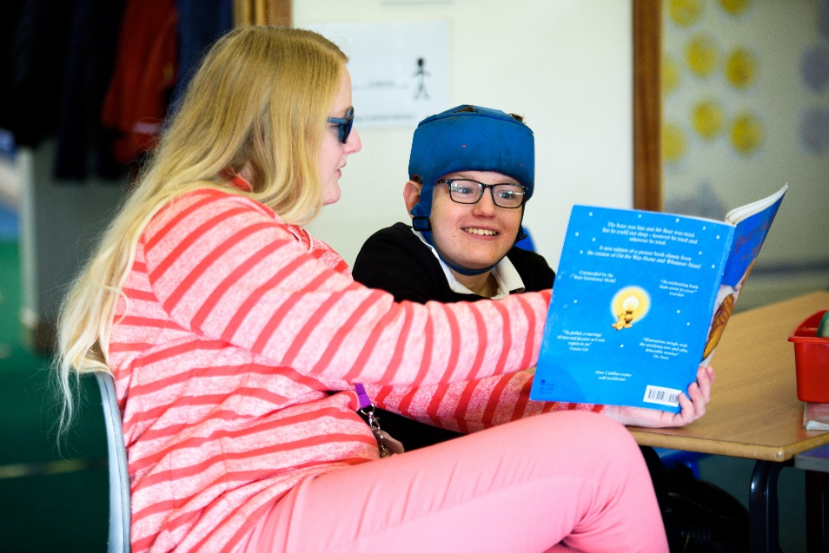
Our team of staff at St Hugh’s have a wealth of expertise and throughout their time in school they continue their professional development (CPD). Some examples of specialist skills and CPD include:

- Access to further education qualifications
- Training from the National Dyslexia Association
- Teachers/TAs with specific specialisms e.g. autism, speech and language, complex medical needs, sex and relationships education (SRE), Trauma Informed Care,
- Makaton language programme using signs and symbols to support communication
- Team Teach positive behaviour management
- Rebound therapy
- On-body signing
- Tac Pac
- Moving and handling
- Specific medical information training
- Training to support young people with sensory differences
- A range of therapy support

What arrangements are in place for assessing and reviewing students’ progress?

Our approach in school is to plan, do and review. We use our own bespoke tracking systems that measures the small steps of progress made by students and helps us provide personalised learning and interventions to help learners progress towards their potential. We also monitor learning through the use of:
- Termly progress meetings between subject leaders and leadership
- Termly interventions planned to accelerate progress if required
- Assessments by outside agencies
- Student review meetings (annual reviews of Education, Health and Care (EHC) Plans)
- Student voice activities
- Annual reports to parents
- Parents’ evenings
- A range of diagnostic assessments to ensure that each student gets the personalised teaching that they need

What access arrangements are there for tests and examinations?
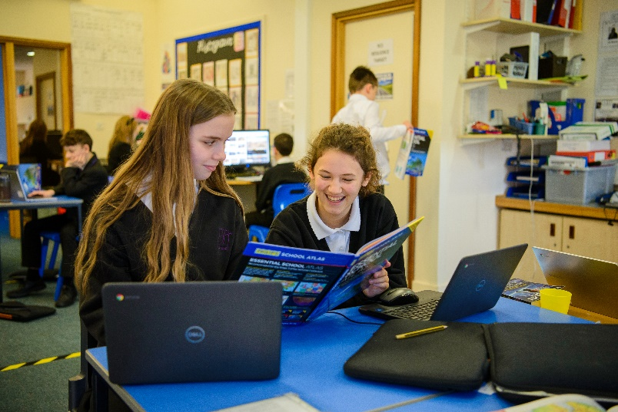
For some students, additional arrangements and adjustments may be needed -qualified by assessment which complies with examination boards’ access arrangements. This might include additional time, rest breaks, a reader or the use of a scribe.
How do we measure the effectiveness of our provision?
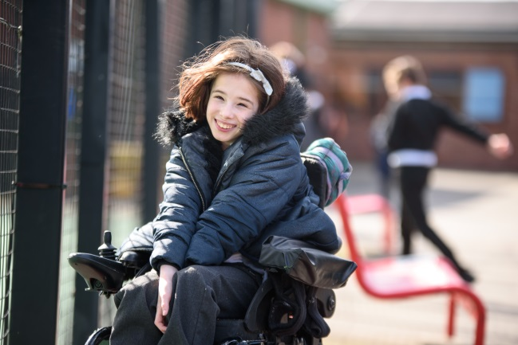 |  | In order to measure the effectiveness of our provision, we encourage feedback from students; either through talking with them or observed behaviour. Observations in many forms are used to review opportunities and practice and feedback from parents is essential. We self-evaluate regularly as a whole school so we stay highly effective and continually improve our what we do. We are also part of the LA’s peer leadership programme so other local and experienced leaders offer professional critique.
What support do we offer to improve students’ emotional and social development?
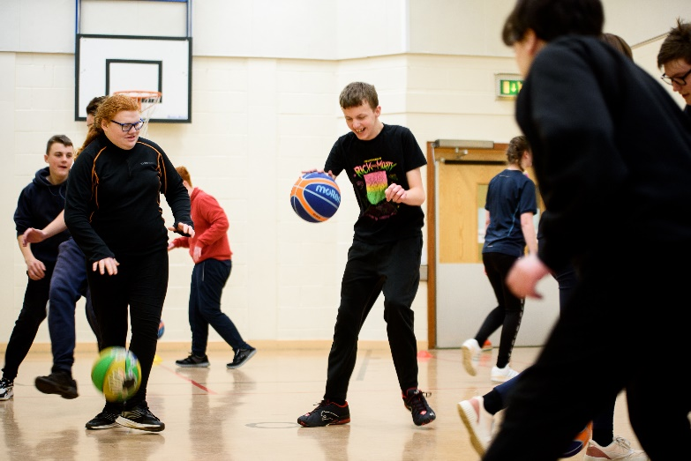
As well as academic progress, we know that supporting our students to develop their emotional and social skills is very important A variety of activities provide opportunities for students to develop as individuals and include:
- Lunchtime clubs
- Out of school learning/community learning opportunities e.g. Outdoor interventions at local providers such as Hackberry, Community Wellbeing Hubs, gardening
- Nurture sessions
- 1:1 sessions
- Taekwondo therapy
- Positive handling plans/behaviour risk assessments
- Nurturing approach
- Play therapy
- Life Coaching sessions
- Horse therapy
- Work experience
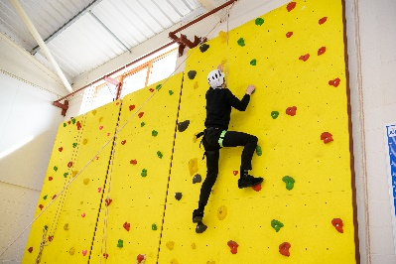
- Sports club
- Variety of enrichment clubs during lunchtime
- Personal care programmes
- Lego therapy
- Rock climbing

Which professional partners do we work with?
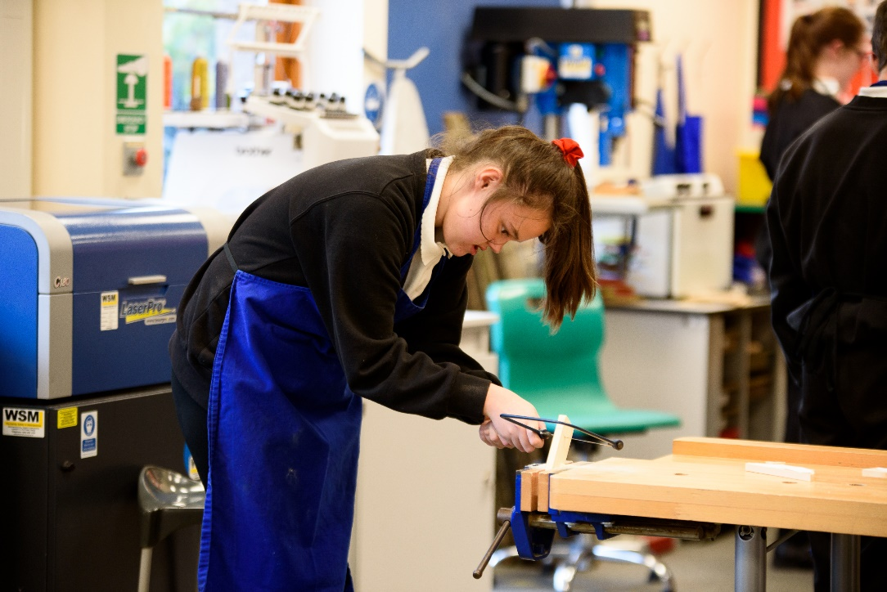

We work together with a number of professional partners to deliver our specialist provision and receive daily support from some of these partners based on site. These include Speech and Language Therapists, Occupational Therapists, Physiotherapists and Nursing staff. In addition to this support we use expertise from:
- Educational psychology service/clinical psychology service (when identified and commissioned by the appropriate service)
- Hearing and visual impairment service (HI/VI).
- Children and Adolescent Mental Health services (CAMHS)
- Integrated Services for Disabled Children (ISDC)
- The Carers’ Support Service
- SENDIASS (Parent Partnership)
- Children’s community nursing team
- FaSST (Families are Safe, Supported and Transformed) workers
- Transitions team and colleagues in adult social care

How do we prepare our students for the future?
Our students can sometimes become anxious around times of transition, whether this is to a new class or a new school. Information sharing meetings take place with the teacher they will be working with. If needed there will be opportunities for students to meet the new class and other key staff.
Support for students moving at the end of year 6:
- Regular visits from April onwards with their year group
- Individual visits if required
- Parents’ coffee event
- Individual parents meetings with KS3 assistant head
- New students begin and current students move up in the last week of the summer term
- Transition booklet and video

Support for students moving at the end of year 11:
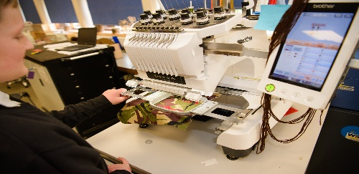
- Regular visits to local colleges to allow students to make informed choices about their next steps
- Visits from college staff
- College taster days
- Support and guidance from careers advisors
- Regular opportunities to discuss transition

Support for students moving at the end of post 16:
- Access to Local Community Wellbeing Hubs to aid students’ transition to adulthood.
- Personalised programmes to ensure students develop skills they require for their chosen options in adulthood.
- Planned time with PAs

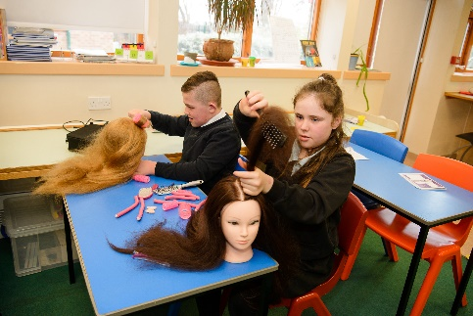

Additional Information
Below you will find a list of websites and organisations that can offer support and guidance.
The North Lincolnshire Council Local Offer
The SEND local offer in North Lincolnshire aims to provide you with information you may need, or want to know, about human resources, service, support, activities and events for North Lincolnshire’s children and young people with Special Educational Needs or Disabilities and their families. Information is arranged according to age from pre- school through to early adulthood. It can be found at the following link: http://www.northlincslocaloffer.com
North Lincolnshire Council website can be accessed at www.northlincs.gov.uk
The SEND Information and Support Service (SENDIAS formerly Parent Partnerships Service)
Royal National Institute for the Blind (RNIB): www.rnib.org.uk
National Autistic Society (NAS) www.autism.org.uk
British Dyslexia Association ( BDA): www.bdadslexia.org.uk
The Carers’ Support Service: www.carerssupportcentre.com/north.lincolnshire/
Epilepsy Action: www.epilepsy.org.uk
Related Polices
Accessibility Policy, Equalities Policy, Special Educational Needs Policy, the school’s prospectus. These may be found on the school website.

